EXP 1: Create a simple cloud software application and provide it as a service using any Cloud Service Provider to demonstrate Software as a Service (SaaS).
DATE:23-02-26
AIM: The aim is to develop a simple, cloud-based application and demonstrate the principles of SaaS by providing access to the software via the cloud, making it scalable, cost-effective, and easily accessible for users.
PROCEDURE:
STEP1:GO TO ZOHOCREATOR.COM AND LOGIN TO YOUR ACCOUNT
STEP2:CLICK CREATE NEW APPLICATION AND CREATE FROM SCRATCH
STEP3: ENTER APPLICATION NAME AND CREATE APPLICATION
STEP4:CLICK ON CREATE NEW FORM AND NAME THE FORM
STEP5:ENTER THE DETAILS
STEP6:THE SOFTWARE HAS BEEN CREATED.

STEP1:GO TO ZOHOCREATOR.COM AND LOGIN TO YOUR ACCOUNT

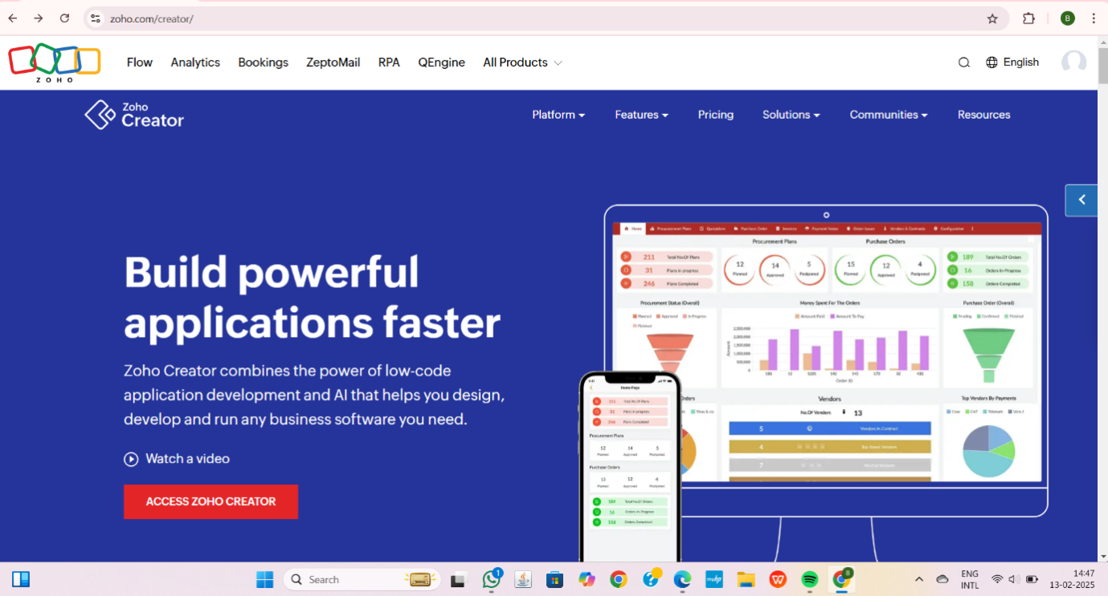

STEP2:CLICK CREATE NEW APPLICATION AND CREATE FROM SCRATCH
STEP3: ENTER APPLICATION NAME AND CREATE APPLICATION

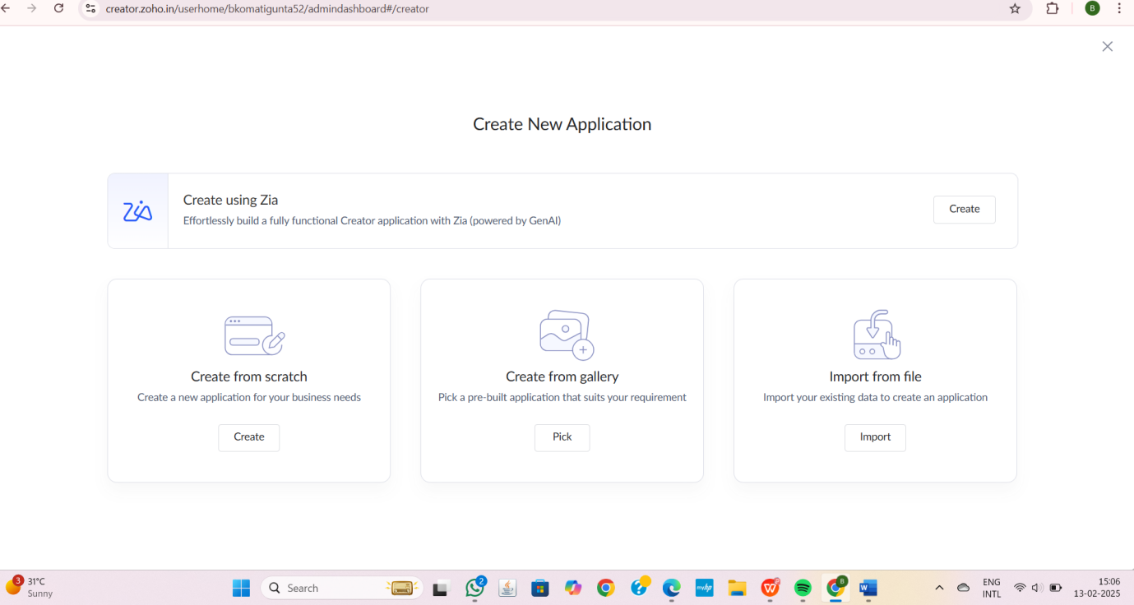

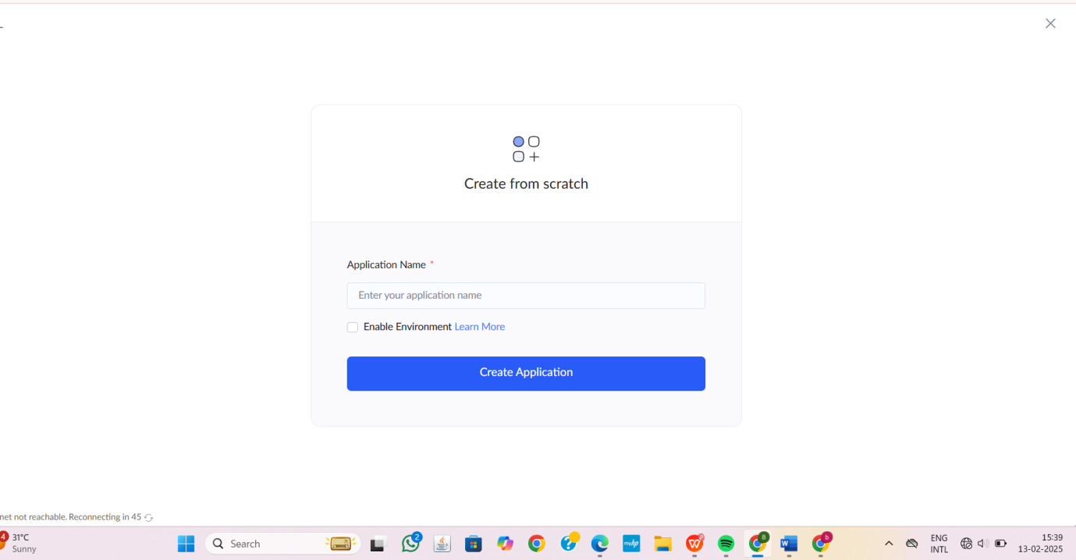

STEP4:CLICK ON CREATE NEW FORM AND NAME THE FORM

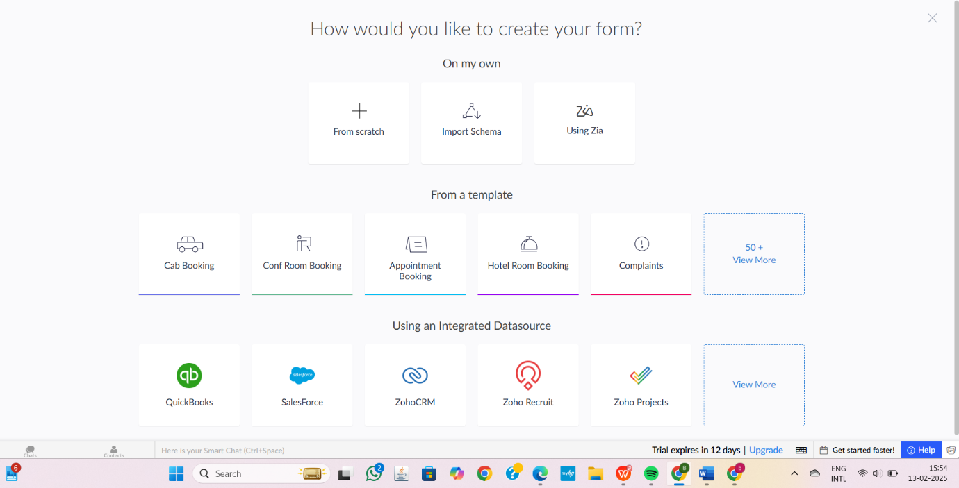

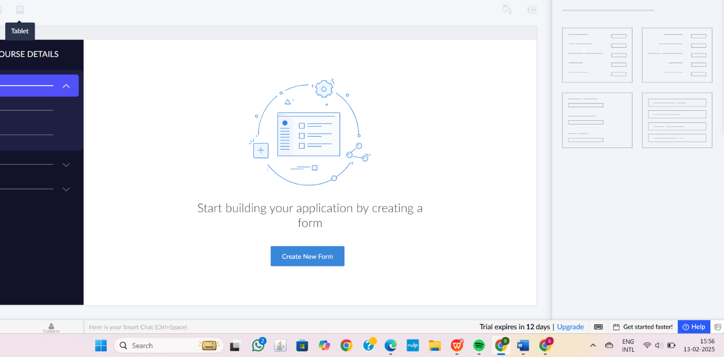

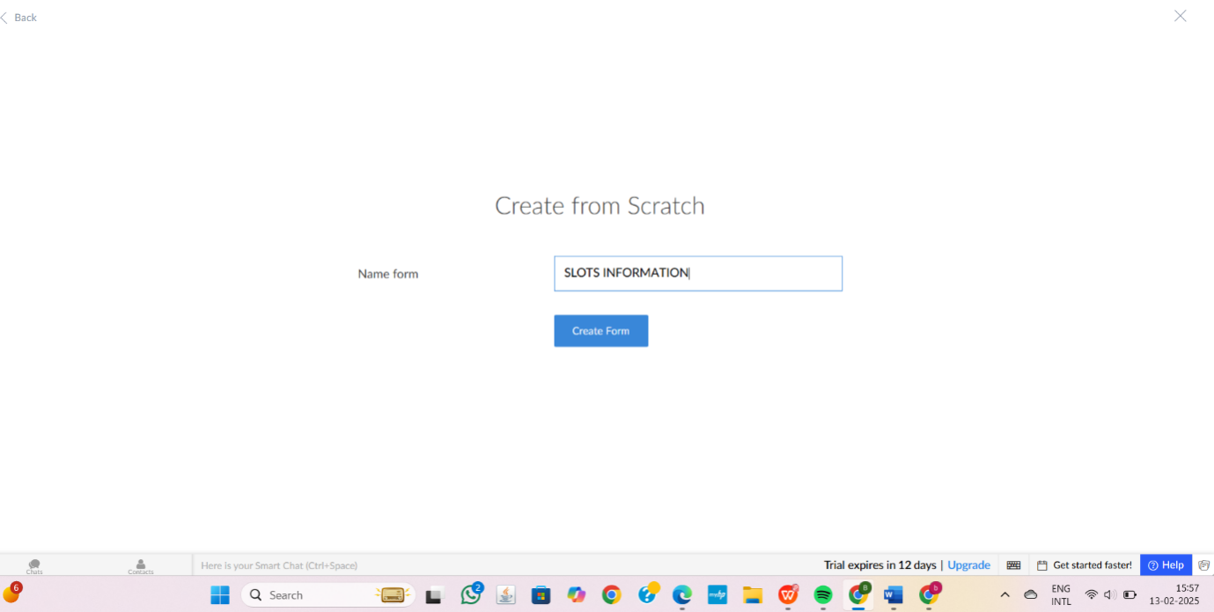
1.SLOTS INFORMATION AND ITS DETAILS

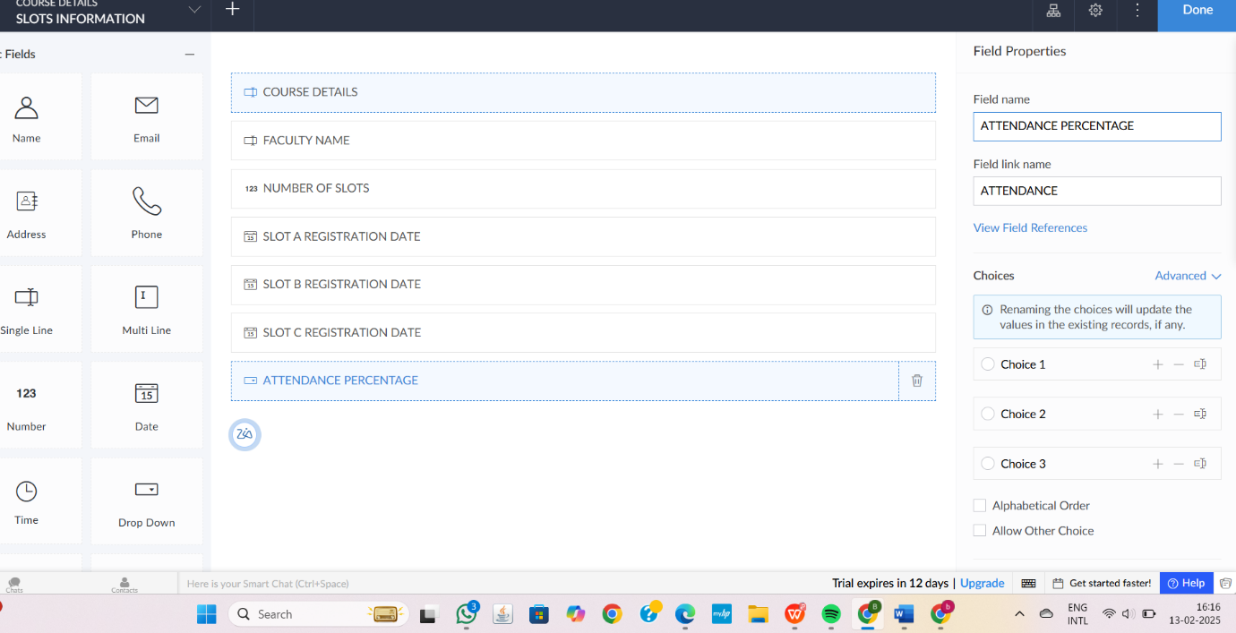

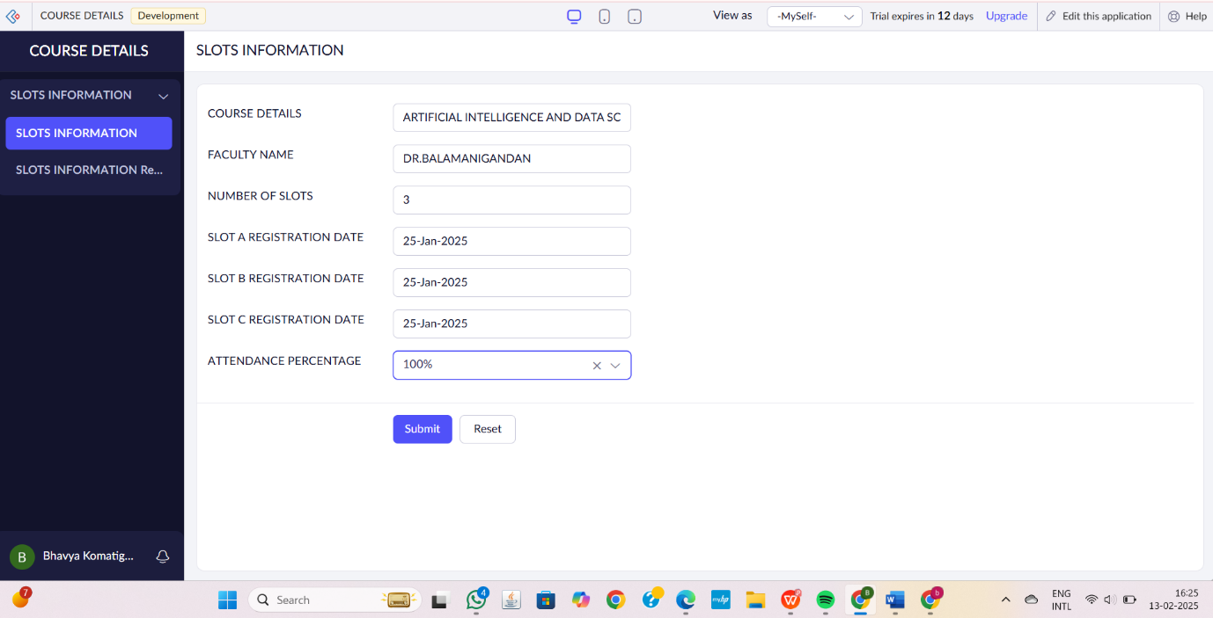
2.FACULTY INFORMATION AND ITS DETAILS
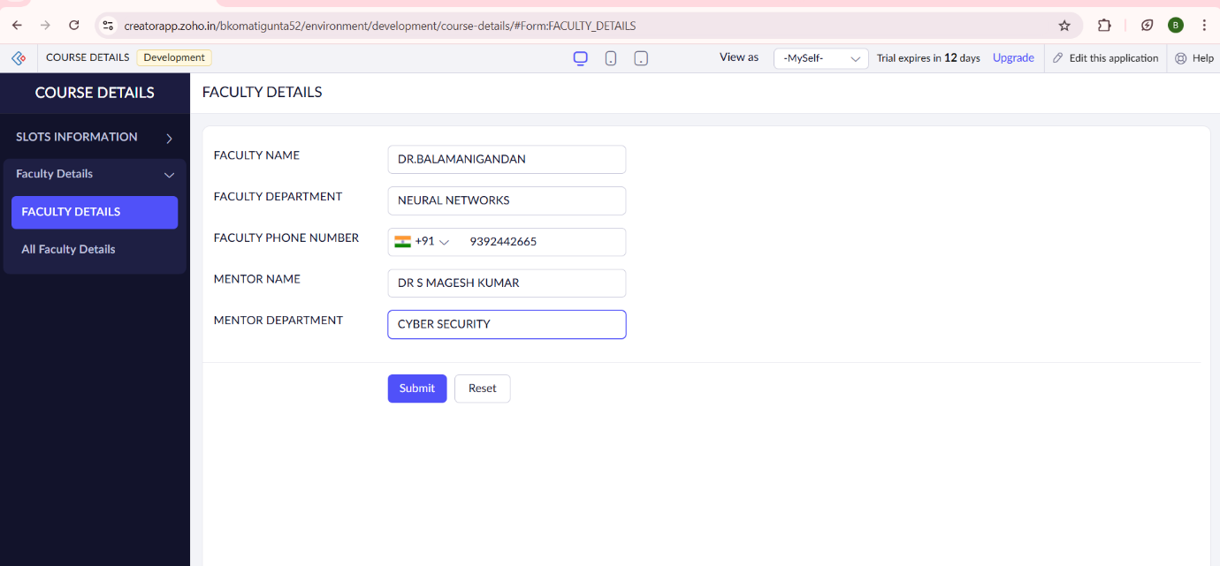

3.SLOT DETAILS
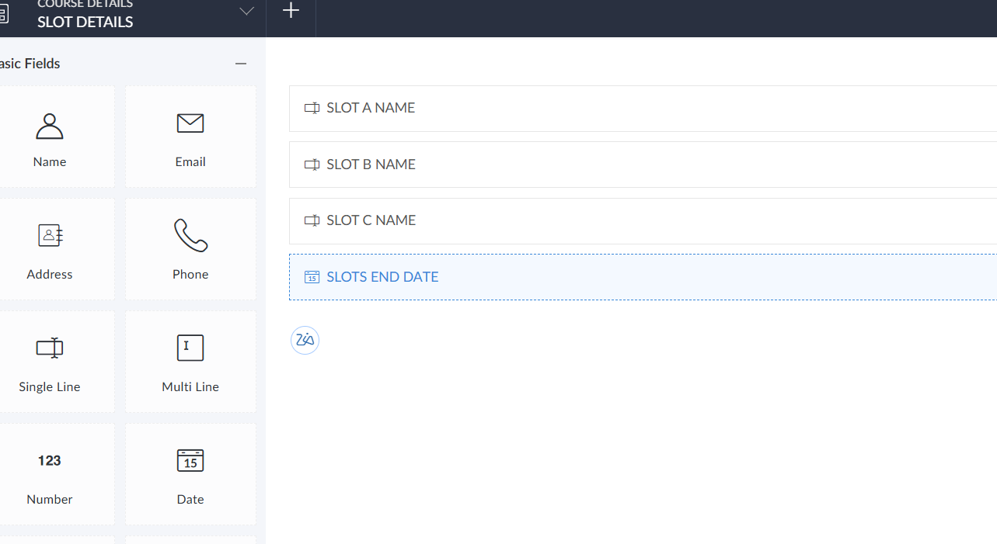

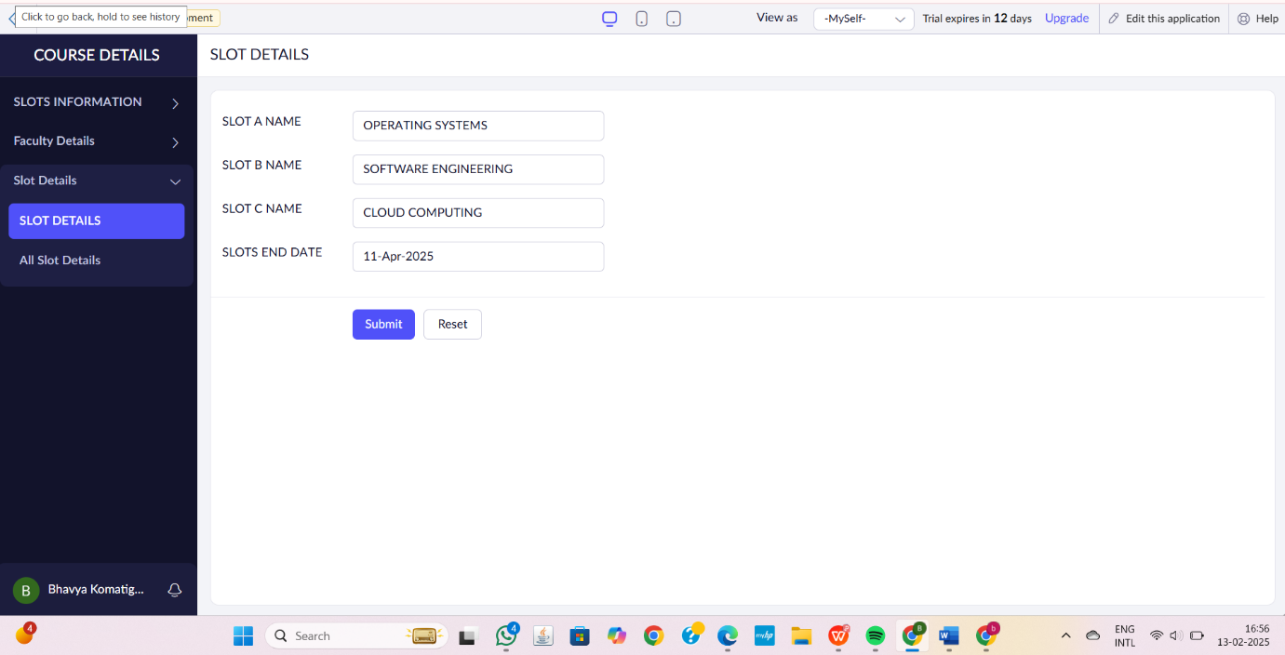
STEP6:THE SOFTWARE HAS BEEN CREATED.

